**Tribhuvan University**

**Institute of Science and Technology**



**Final Year Internship Report**

**On**

**Web Front End Of**

**“CODEIT Bot: Revolutionizing Intern Hiring” At**

**CODE IT**

**(Course Code: CSCC-462)**

Internship Report Submitted in the Fulfillment of the Requirement for the

**Bachelor of Science in Computer Science & Information Technology**

**under Tribhuvan University, Nepal**

**Submitted By:**

**Bishal Giri (24600/076)**

**TU Registration No.:** **5-2-0459-0001-2019**

**Submitted To:**

**Department of Computer Science and Information Technology**

**Birendra Memorial College**

**Dharan-1, Sunsari,**

**Nepa****l**

SUPERVISOR’S RECOMMENDATION

I hereby recommend the internship report prepared under my supervision by Bishal Giri entitled” **CODEIT Bot: Revolutionizing Intern Hiring**” in partial fulfillment of the degree of BSc. Computer Science and Information Technology be process of evaluation.

…………………………………………

**Er.Pravin Sangroula**

Supervisor

Birendra Memorial College

Department of Computer Science and Information Technology

Bhupi Marga , Dharan-4

# EXAMINERS’ APPROVAL LETTER

This is to certify that this project prepared by **Bishal Giri** entitled “**CODEIT Bot: Revolutionizing Intern Hiring”** in partial fulfillment of the requirement for the degree of B.Sc. in Computer Science and Information Technology has been well studied. In our opinion it is satisfactory in scope and quality as a project for the required degree.

|  |  |
| --- | --- |
| 1.  ………………………  Supervisor: Er. Pravin Sangroula  Birendra Memorial Collage  Department of Computer Science and  Information Technology | 2.  …………………….  Head of Department: Er. Mukesh Shah  Birendra Memorial Collage  Deparment of Computer Science and  Information Technology |
| 3.  …………………….  External Examiner: |  |

# ACKNOWLEDGEMENT

I am very thankful to **Mr. Mukesh Shah**, Head of Department, Bsc. CSIT of Birendra Memorial Collage, for providing me regular feedback and suggestions to perform the internship project assignment so that we can practically implement the knowledge we gained during the program.

I am very glad to take the opportunity to express my guidance, support and valuable suggestions and coordination till the completion of the internship program, **Mr. Sajal Shrestha** for the guidance, support and valuable suggestions and coordination till the completion of the internship program. I would like to thank him and express my sincere gratitude for believing in me and giving me the chance to complete my internship within the uncertainty of time. It was indeed a great learning experience and remarkable career opportunity for me.

I am very grateful to **Code IT Appsware** in providing all the necessary feedback, help and support for the entire development of the project as well as the infrastructure provided during my internship period.I am very thankful for their cooperation and support, without which it would never would have been possible to complete the internship assessment.

Finally, I would like to express my sincere gratitude to all my family, friends and others who helped me directly and indirectly during the internship period.

Sincerely,

**Bishal Giri (24600/076)**

# ABSTRACT

This internship report contains the details of the activities carried out during the

internship conducted at Code IT Appsware ,Dharan, Sunsari for an 8-week period. My internship at Appsware was a hands-on experience where I got to learn about system development, the agile workflow, and team work in real-time. I gained valuable knowledge and practical skills from our mentor and other experienced professionals. Additionally, this experience taught me the importance of teamwork and how to be an effective member of a group. During my internship, I worked as a Frontend Developer for an “CodeIT Bot” using React and Node.js.

The system I worked on is a web application designed to conduct a prequalification coding exam for students and general users aspiring to apply for internships at Code IT. Before directly contacting the HR department, applicants will be directed to this software. The software administers a series of online tests and forwards the CVs of only those candidates who achieve high scores. Additionally, users can review their submitted answers to identify mistakes and improve their performance in future attempts

**Keyword:** *Agile workflow , CodeIT bot ,Frontend Development, React, Node.js* **,** *web-based application*

**TABLE OF CONTENT**

SUPERVISOR’S RECOMMENDATION i

EXAMINERS’ APPROVAL LETTER ii

ACKNOWLEDGEMENT iii

ABSTRACT iv

LIST OF ABBREVIATIONS vii

LIST OF FIGURES viii

LIST OF TABLES ix

CHAPTER 1 : INTRODUCTION 1

1.1 Introduction 1

1.2 Problem Statement 2

1.3 Objective 2

1.4. Scope and Limitation 3

1.4.1 Scope 3

1.4.2 Limitation 3

1.5. Report Organization 4

CHAPTER 2: ORGANIZATION DETAILS AND LITERATURE REVIEW 5

2.1 Introduction to Organization 5

2.2 Organization Hierarchy 6

2.3 Working Domains of Organization 8

CHAPTER 3: INTERNSHIP ACTIVITIES 11

3.1. Roles and Responsibilities 11

3.2. Weekly log 12

3.3. Description of the Project Involved During Internship 13

3.3.1 Introduction to a system 13

3.3.2 Objectives of the System 14

3.3.3 Functions of the System 14

3.4. Tasks / Activities Performed 15

3.4.1 Learning about React and Tailwind CSS 15

3.4.2 Learning about Node js and Express 15

3.4.3 Integrating React with Node.js and Express.js 16

3.4.4 Using the Nodemailer API for Sending Emails 16

3.4.5 Using an API for Code Compilation 17

CHAPTER 4: CONCLUSION AND LEARNING OUTCOMES 18

4.1 Conclusion 18

4.2 Learning Outcomes 18

REFERENCES 19

APPENDIX 20

# LIST OF ABBREVIATIONS

|  |  |
| --- | --- |
| **API** | Application Programming Interface |
| **CV** | Curriculum Vitae |
| **CSS** | Cascading Style Sheets |
| **DOM** | Document Object Model |
| **GDPR** | General Data Protection Regulation |
| **HR** | Human Resource |
| **HTTP** | Hypertext Transfer Protocol |
| **IT** | Information Technology |
| **MCQ** | Multiple Choice Question |
| **UI** | User Interface |
| **UX** | User Experience |
|  |  |

# LIST OF FIGURES

Figure 1 : Organization hierarchy 7

Figure 2 : Structure of our node js folder 20

Figure 3 : Integrating reactjs and nodejs 20

Figure 4 : Structure of Piston API for code compilation 21

Figure 5 : Homepage of system 21

Figure 6 : Contact page of system 22

Figure 7 : About page of system 22

Figure 8 : Footer of system 23

Figure 9 : User Authentication page 23

Figure 10 : Final View of User Authentication 24

Figure 11 : MCQ page UI design for showing wrong answer 24

Figure 12 : Code Editor page where user enter answer 25

Figure 13 : User reviewing his answer provided in code editor 25

Figure 14 : Sending mail with CV to HR if user passed the exam 26

Figure 15 : Interface shown to user if he fails the exam 26

# LIST OF TABLES

Table 1 : Organization detail 5

Table 2 : Major Projects by Code IT Appsware 8

Table 3 : Detail of internship 9

Table 4 : Weekly Log 12

# CHAPTER 1 : INTRODUCTION

As a part of the course requirement of the 8th semester of the Bachelor of Science Computer

Science and Information technology (BSc CSIT) degree of Tribhuvan University, all students are

required to complete a six credit (minimum 10 weeks/180 hours long) internship.

The internship experience is expected to assist the students to face complex real world problems.

Going to a college or university is a critical step, but one can greatly enhance their classroom

learning by gaining real world experience through college student internships. In addition to

gaining great experience to complete our classroom learning, college internships allow us to beef

up our portfolio or résumé and make valuable industry contacts that can be essential to landing

the ideal job upon graduation.

Further, as college student internships are also competitive, one can make the most of other

opportunities available to them by finding a campus job in their field. College internships are

beneficial because they get us both experience and contacts.

Graduating students with paid or unpaid internships on their résumé have a much better chance

at landing a full-time position upon graduation. Students are doing internships as undergraduates,

and it is now not unusual for recent grads to take an unpaid internship with hopes of turning it

in

As a part of the course requirement of the 8th semester of the Bachelor of Science Computer

Science and Information technology (BSc CSIT) degree of Tribhuvan University, all students are

required to complete a six credit (minimum 10 weeks/180 hours long) internship.

The internship experience is expected to assist the students to face complex real world problems.

Going to a college or university is a critical step, but one can greatly enhance their classroom

learning by gaining real world experience through college student internships. In addition to

gaining great experience to complete our classroom learning, college internships allow us to beef

up our portfolio or résumé and make valuable industry contacts that can be essential to landing

the ideal job upon graduation.

Further, as college student internships are also competitive, one can make the most of other

opportunities available to them by finding a campus job in their field. College internships are

beneficial because they get us both experience and contacts.

Graduating students with paid or unpaid internships on their résumé have a much better chance

at landing a full-time position upon graduation. Students are doing internships as undergraduates,

and it is now not unusual for recent grads to take an unpaid internship with hopes of turning it

in

## Introduction

The internship program, a mandatory component of the Bachelor of Science in Computer Science and Information Technology (B.Sc. CSIT) degree at Tribhuvan University, holds significant importance for students in their 8th semester. Industry internships offer CS students an opportunity to gain authentic disciplinary experiences, evaluate self-interests, and secure future employment. I worked as an intern at Code IT as a Frontend Developer for 11 weeks on the project “CodeIT Bot”.

CodeIT Bot is a web-based system designed to conduct prequalification coding exams for students and general users aspiring to apply for internships at Code IT. This application serves as a preliminary screening tool, directing applicants to complete a series of online tests before directly contacting the HR department. The system ensures that only those candidates who achieve high scores have their CVs forwarded for further consideration. Additionally, it allows users to review their submitted answers to identify mistakes and improve their performance in future attempts.

The web application, built using the Nodejs and Reactjs , implements strict authentication and authorization mechanisms to ensure secure access. It provides a user-friendly interface where applicants can log in, take coding tests, and view their results. The portal enhances the recruitment process by filtering out less qualified candidates, thereby saving time and resources for the HR department.

The need for this system arises from the challenges associated with manual pre-screening of numerous applicants, which can be time-consuming and inefficient. By automating the initial assessment phase, CodeIT Bot addresses these challenges, ensuring a more streamlined and effective selection process for internships. With robust security measures and an intuitive design, the system safeguards data privacy and enhances user experience, making it a valuable tool for Code IT.

## Problem Statement

Some the major problems are :

* Code IT faces challenges in efficiently prequalifying candidates for internship positions.
* The traditional method of manually reviewing numerous applications is time-consuming.
* Conducting initial screenings manually is resource-intensive for the HR department.
* There is a need for a streamlined process to ensure only the most qualified candidates proceed to the next stages of recruitment.

## 1.3 Objective

The major objective of internship are:

* To expose student to a particular job and a profession or industry.
* To provide student with opportunity to develop skills in the field of interest.
* To assist students in gaining vital work related experience and building strong resume for bright career.
* To help students in developing business contacts i.e. creating network contacts.
* To help students potentially land permanent or contracted jobs from host company.

## 1.4. Scope and Limitation

### 1.4.1 Scope

This internship report details the activities and experiences during my 8-week internship at Code IT Appsware in Dharan, Sunsari. At Appsware, I deepened my understanding of system development, agile workflow, and teamwork in a professional setting, guided by our mentor and other experienced professionals.

As a Frontend Developer, I worked on the "CodeIT Bot" project using React and Node.js. This web application conducts prequalification coding exams for internship applicants, forwarding only high-scoring candidates' CVs to HR. It also allows users to review their answers for future improvement.

The report highlights my professional growth, challenges overcome, and insights gained. It details the "CodeIT Bot" features and technologies, and underscores the importance of effective communication and agile methodologies within the development team.

This report is a testament to the enriching and transformative experience I had at Code IT Appsware, showcasing the skills and knowledge I acquired.

### 1.4.2 Limitation

Everything has its limitations. So, some of the major limitations of the internship are:

* Each and every part of the functioning of the organization has not been described as there are restrictions due the privacy policies of the organization.
* Economic details of the project have not been mentioned due to confidentiality issues.
* There was limited amount of time overseeing the complexity of the project.

\

## 1.5. Report Organization

This report is divided into four chapters:

Chapter 1: The project is described in depth, including the problem statement, its objectives, scope and limitations.

Chapter 2: The organization hierarchy, working domains and intern department unit is described in depth. It also features a Literature Review.

Chapter 3: This chapter provides details on activities performed during internship period. It includes roles and responsibilities assigned, weekly log, description of projects(s) involved along with the technical details of the activities performed during internship.

Chapter 4: This chapter offers the internship conclusion and learning outcomes.

# CHAPTER 2: ORGANIZATION DETAILS AND LITERATURE REVIEW

## 2.1 Introduction to Organization

Code IT Appsware is a certified software development and web development company based in Nepal and headquartered in Prithivi Path, Dharan-1. Code IT Appsware is providing IT solutions and IT-enabled services. Ever since their establishment, they are growing everyday to meet the growing demand of the clients and surpass their experience.

Code IT Appsware expertise in providing industry-specific solutions and custom services has enabled to deliver absolute business solutions to their worldwide clients. Code IT Appsware is providing services to small as well as big corporate houses including individuals, entrepreneur using their unmatched expertise and cutting-edge technology.Code IT Appsware strongly competent in desktop as well as web-based application. Code IT Appsware with its vast skill-set and proven competency in technology sector has won accolades from their nationwide clients.

Table 1 : Organization detail



|  |  |
| --- | --- |
| Organization Name | Code IT Appsware |
| Address | Dharan-1,Sunsari,Koshi Pradesh, Nepal |
| Contact no | [025-575163](tel:025-575163) |
| Mail | [info@codeit.com.np](mailto:info@codeit.com.np) |
| website | https://codeit.com.np/ |

## 2.2 Organization Hierarchy

The organization structure of Code IT Appsware is composed of Board of Directors (BOD) which is followed by the Managing Director (MD) who is the executive chief of the Code IT Appsware, who is responsible for steering the company,

Directly under MD, Code IT Appsware has one director which is followed by a Chief Officer and then two Assistant Director (Production) and Assistant Director (Consultancy Support) heading two different departments:

* Production
* Consultancy Support

Under the Chief Operating Officer, there is a working unit which is compromised of the System Analyst, Software Engineers, Network Engineers, Programmers, Trainers, Report Writers and Database Administrator (DBA). The MD looks after the functions such as Administration, Customer Support Unit, Financial Management, Human Resource, Quality Analyst and Testing Engineers.

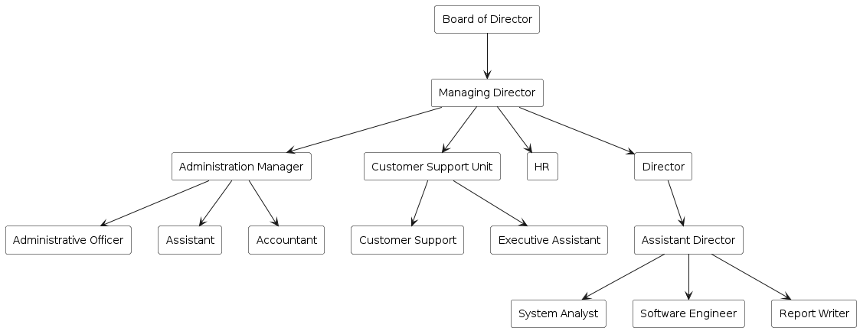

Figure 1 : Organization hierarchy

## 

## 2.3 Working Domains of Organization

Code IT Appsware is more subjective to the mobile application development and web application development and design. With respect to these platforms, the organization has some of the projects up and running as listed below:

Table 2 : Major Projects by Code IT Appsware

|  |
| --- |
| Account Mate |
| Easy Billings |
| Bandaki++ |
| Ichef |
| Everestdailynews.com |
| Hotelsandhyainn.com |
| Buddhashanti.com |
| Wakecup Coffee |
| Attendance App for Central Campus of Technology |
| Dharan Care App for Dharan Sub-Metropolitan |
| Onwaymechanics |
| Export From Nepal |

**2.4 Department of Intern Department**

The Software Development Department at Code IT or CodeIT Appsware lead by **Er.Sajal Shrestha** is a dynamic and innovative unit responsible for creating and maintaining cutting-edge software solutions. This department plays a critical role in the organization's mission to provide advanced technological services and educational tools.

The Software Development Department focuses on developing a wide range of applications, from mobile and web applications to complex enterprise systems. This unit is dedicated to delivering high-quality software that meets the needs of both internal stakeholders and external clients.

Table 3 : Detail of internship

|  |  |
| --- | --- |
| Start Date | 5 March , 2024 |
| End Date | 6 June , 2024 |
| Total Duration | 3 month |
| Intern Position | Frontend developer |
| Mentor | Mr. Sudam Shrestha |
| Office Hour | 11 AM – 4PM |

**2.5. Literature Review**

Online examination systems have become a crucial component of modern educational and recruitment processes, evolving from limited early systems to sophisticated platforms offering automated test administration, real-time evaluation, and comprehensive reporting. Online Examination is an essential ingredient in electronic and interactive learning, however, in educational environment most of examinations are done in the classical paper-based way due to the lack of resumption capability when power/network/physical computer’s component failures.Online Examination System is a web application that sets up a system between the establishments and understudies. These systems provide significant benefits, including wider reach, consistent and objective evaluations, and features like real-time feedback and performance analytics, aiding candidates in skill improvement. Security is paramount, with literature emphasizing secure authentication, encryption, and monitoring tools to maintain integrity. Organizations can also easily monitor the progress of the student that they give through an examination. Compliance with data protection regulations, such as GDPR, is essential, necessitating regular audits and transparent reporting.

The future of these systems is expected to be driven by AI and machine learning, enhancing personalization and grading, with technologies like blockchain ensuring security and transparency.  The main task of AI during the exam time can be the continuous live detection of every candidate and for this facial detection using a webcam is necessary. Despite the benefits, challenges remain in ensuring data privacy and legal compliance. The field continues to evolve, focusing on security, user experience, and integrating emerging technologies to meet the needs of institutions and organizations.

# CHAPTER 3: INTERNSHIP ACTIVITIES

## 3.1. Roles and Responsibilities

Here were some of the key responsibilities as intern in a company:

* **Requirement Analysis**: Collaborating with senior developers and stakeholders to gather and analyze requirements for the online qualifying exam software.
* **Software Development**: Writing code for various components of the application using relevant programming languages and frameworks. This will involve both front-end and back-end development tasks.
* **User Interface Design**: Helping to create intuitive and user-friendly interfaces for the online exam platform, ensuring a seamless experience for users.
* **Testing and Debugging**: Participating in the testing phase to identify and fix bugs, ensuring the software functions correctly and efficiently.
* **Collaboration**: Working closely with other team members, including software engineers, system analysts, and quality assurance specialists, to ensure the successful completion of the project.
* **Feedback and Improvement**: Gathering feedback from users and making necessary adjustments to improve the software's functionality and user experience.

## 3.2. Weekly log

The weekly tasks done during the internship are as given below:

Table 4 : Weekly Log

|  |  |
| --- | --- |
| Weeks | Works |
| Week 1 | Introduction to the team and research for learning was done. |
| Week 2 | Researching about the way to validate user and implemented user authentication |
| Week 3 | Finding out the way to validate user answer and implemented the resulting idea to validate user’s answer of code editor |
| Week 4 | Find out the way to give score for user answer and implemented scoring system |
| Week 5 | Developed frontend interfaces for exam-taking, review, and tracking the user score and details. |
| Week 6 | Integrated frontend with backend for seamless communication and defined the proper routing |
| Week 7 | Integrated timing mechanism with clock in the website giving only limited time to user to solve the question. |
| Week 8 | Integrated the system where after finishing the test, user can download and review their provided answer and automatically send the mail to HR team with user’s CV only if user pass the exam |
| Week 9 | Conducted manual testing and debugging to ensure functionality and reliability. |
| Week 10 | Made small adjustments to how the website looks and works based on feedback from people testing it, so it's easier and more enjoyable for users |
| Week 11 | Perform more user answer validation technique by modifying the algorithm |
| Week 12 | Finalize the software with all the necessary testing and validation |

## 3.3. Description of the Project Involved During Internship

## 

### 3.3.1 Introduction to a system

In today's competitive job market, securing an internship opportunity requires not only academic credentials but also demonstrable skills in coding and problem-solving. This report outlines the development and implementation of a web application designed to streamline the internship application process at Code IT. Over the course of a two-month internship, the focus was on creating a platform that facilitates the prequalification coding exam for prospective interns.

The primary aim of this web application is to provide a standardized assessment tool for students and general users aspiring to apply for internships at Code IT. Rather than directly contacting the HR department, applicants are directed to this software, which administers a series of online tests tailored to evaluate their coding proficiency and problem-solving abilities.

One of the key features of this system is its ability to forward the CVs of only those candidates who achieve high scores in the prequalification coding exam. By automating this initial screening process, the application helps to efficiently identify top talent, saving time and resources for both applicants and the HR department.

Additionally, the system offers a valuable learning opportunity for users by allowing them to review their submitted answers. This feature enables candidates to identify mistakes, understand their strengths and weaknesses, and improve their performance in future attempts. Thus, not only does the web application serve as a gateway to internship opportunities at Code IT, but it also functions as a tool for continuous learning and skill development.

Throughout this report, we will delve into the details of the activities undertaken during the internship period, from the conceptualization and design of the web application to its implementation, testing, and final deployment. Moreover, we will explore the impact of this system on the internship application process and its potential implications for recruitment practices in the tech industry.

### 3.3.2 Objectives of the System

The objectives of this system are:

* Automate prequalification coding exams.
* Identify top talent based on coding proficiency.
* Streamline the HR screening process.
* Improve resource allocation for HR.
* Provide feedback for continuous improvement.
* Foster skill development among candidates.
* Optimize the internship application process.
* Promote fair and transparent candidate evaluation.

### 3.3.3 Functions of the System

The function of proposed system are as follow :

* Automate coding exams.
* Identify top talent.
* Efficient filtering of talents.
* Enhance user experience.
* Provide feedback for improvement.
* Foster skill development.
* Optimize application process.Top of FormBottom of Form

## 3.4. Tasks / Activities Performed

During my internship period at Code IT Appsware, my personal objective was to gain knowledge on React based software development. This was possible due to being able to learn the use of different tools and techniques through out my internship and thanks to that I am now able to develop a functional React application with responsive and user-friendly UI.

### 3.4.1 Learning about React and Tailwind CSS

React is a popular JavaScript library developed by Facebook for building user interfaces. It allows developers to create interactive and dynamic web applications efficiently.

Tailwind CSS is a utility-first CSS framework that provides a highly customizable set of design utilities. It allows developers to style their applications directly in their HTML or JSX using predefined classes.

In the proposed system, React was used to build the dynamic user interfaces for the application allowing for a responsive and interactive experience for users taking the prequalification coding exams. React's component-based architecture facilitated the creation of reusable UI elements, enhancing the maintainability and scalability of the application. Tailwind CSS was employed to style these components, providing a utility-first approach to design that enabled rapid and consistent styling across the application. Tailwind's pre-configured classes allowed for a streamlined development process, ensuring a visually appealing and user-friendly interface..

### 3.4.2 Learning about Node js and Express

Node.js is a powerful runtime environment that enables developers to run JavaScript code outside of a web browser. It is built on Chrome's V8 JavaScript engine and is known for its event-driven, non-blocking I/O model.

Express.js is a minimal and flexible web application framework built on top of Node.js. It provides a robust set of features for building web and mobile applications.

On our system’s backend, Node.js was utilized for its event-driven, non-blocking I/O model, which is ideal for building scalable network applications. Node.js enabled the development of a robust server that could handle multiple simultaneous connections efficiently. Express, a minimalist web framework for Node.js, was used to manage the application's routing and middleware, facilitating the creation of RESTful APIs that seamlessly connected the frontend with the backend. Express's simplicity and flexibility allowed for efficient handling of user authentication, exam submission, and CV forwarding functionalities. Additionally, the integration of Nodemailer API with Node.js and Express ensured the reliable delivery of OTPs for user login and the automatic sending of CVs to the HR department, enhancing the overall functionality and user experience of the "CodeIT Bot" application.

### 3.4.3 Integrating React with Node.js and Express.js

The function of React and Node.js with Express.js was integrated together to allow them all to function properly and seamlessly. Basic routing was done in a system with their proper parameter being passed to each pages till the end.

### 3.4.4 Using the Nodemailer API for Sending Emails

Top of Form

Bottom of Form

Nodemailer is a module for Node.js applications to send emails easily. It provides a simple and efficient way to handle email sending in a server-side application, making it ideal for scenarios like sending confirmation emails, notifications, or error reports.

Here in our system, we have used node mailer to sent OTP to user provided email to validate his email.Also after exam finished , then Nodemailer is used to sent CV to the HR team of Code IT.

### 3.4.5 Using an API for Code Compilation

In our purposed system, Piston API have been used for code compilation.

Using an API for code compilation, such as the Piston API, allows developers to execute code written in various programming languages seamlessly within their applications. By making HTTP POST requests to the API, developers can send the source code and the desired programming language, and receive the execution results. For example, using Axios in a Node.js environment, you can create a function executeCode to compile and run code by sending a request to the Piston API with the code and language details, then returning the output, enabling the integration of real-time code execution capabilities into web applications or coding platforms.

# CHAPTER 4: CONCLUSION AND LEARNING OUTCOMES

## 4.1 Conclusion

During the internship period, I familiarized myself with React and Nodejs. The internship started with me learning the basics of React and tailwind like how to set up a project and the basics of UI designing. I designed initial UX and UI for this application and had a hand in the development of this application. The first step in development of the app was making the interactive UI using React and tailwind and. After the design was made, the coding part of the application development began. We first worked on Login Page and then to Code Editor page. After this we designed MCQ page. And then after spending lot of time in validating the user code in code editor page we proceed to MCQ page.In MCQ page, certain UI functionality were used to inform user about his answer whether his provided answer was correct or incorrect. After completing all this task , making an efficient routing was crucial. So we managed to complete all the routing task.

The internship at Code IT Appsware helped the internee to build up confidence and gain valuable knowledge and experience in IT especially in the development of Mobile Applications preparing them to tackle real word competition and meet the real world demand.

## 4.2 Learning Outcomes

Everything we have learnt and gained knowledge is important and useful in some part of our life. Some of the major lessons learnt during the internship program can be listed as follows:

* Learned about basics of React and Node.
* Learned about APIs and seamless flow between react and node.
* Learned communication skills to work in a team effectively.
* Learned about the software development procedures.
* Learned limited time and resource management.

# REFERENCES

Kapoor, A. a.-M. (2020). Exploring the participation of CS undergraduate students in industry internships. *Proceedings of the 51st ACM Technical Symposium on Computer Science Education* , 1103-1109.

Kotwal, D. V. (2016). Online examination system. *International Research Journal of Engineering and Technology (IRJET* , 115-117.

Sapre, S. S. (2021). AI-ML based smart online examination framework. *International conference on deep learning, artificial intelligence and robotics* , 17-25.

SWeaver, D. e. (2005). Evaluation: WebCT and the student. *Evaluations and Assessment Conference* .

Younis, M. I. (2015). Construction of an online examination system with resumption and randomization capabilities. *International Journal of Computing* , 62-82.

# APPENDIX

Appendix A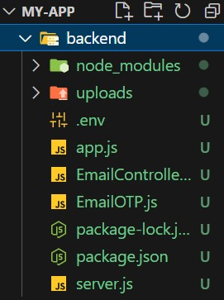

Figure 2 : Structure of our node js folder

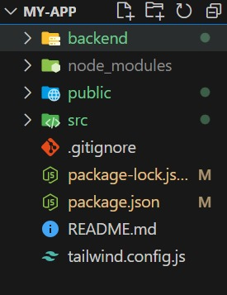Appendix B

Figure 3 : Integrating reactjs and nodejs

Appendix C

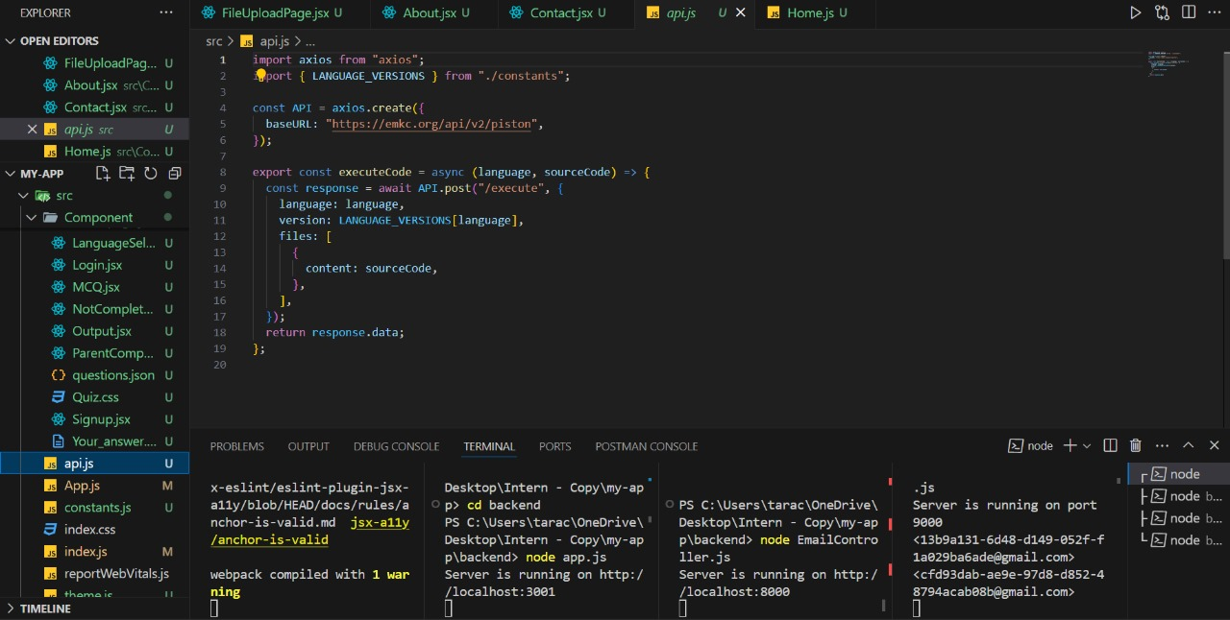

Figure 4 : Structure of Piston API for code compilation

Appendix D

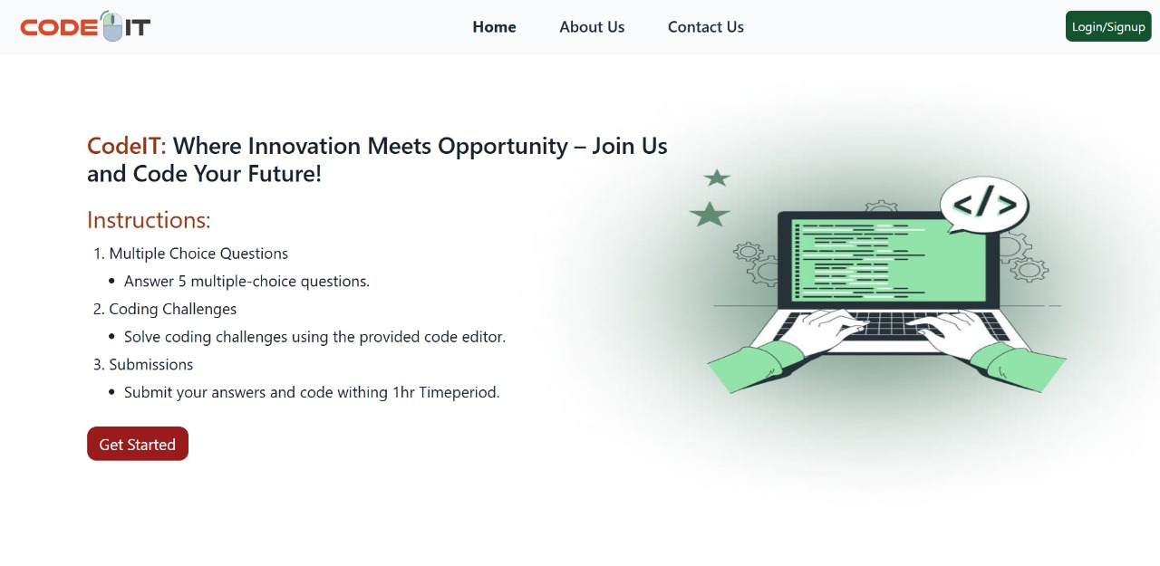

Figure 5 : Homepage of system

Appendix E

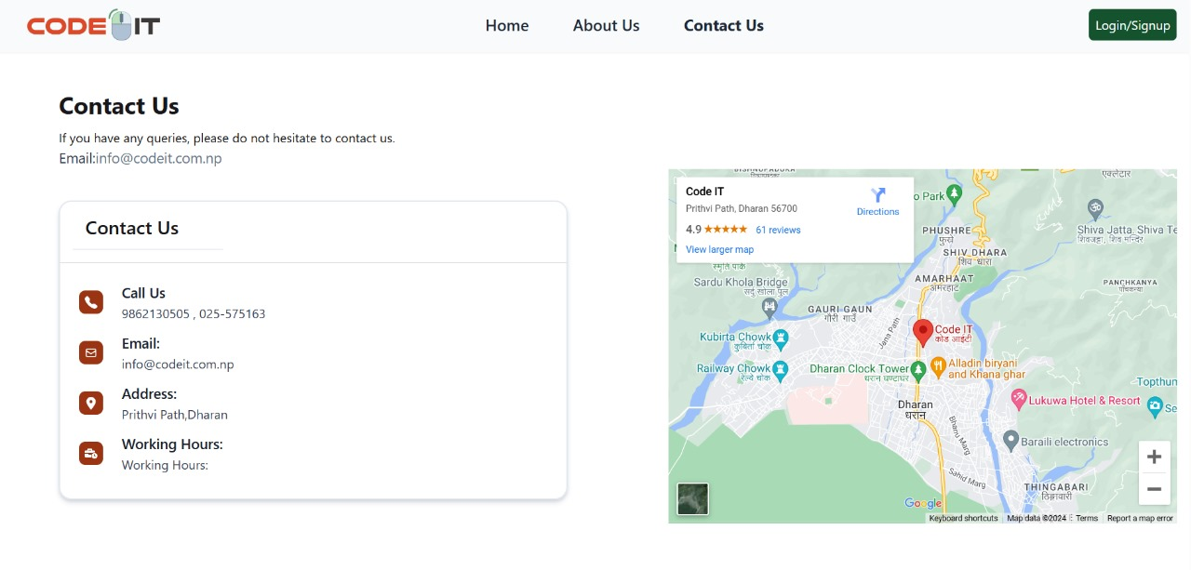

Figure 6 : Contact page of system

Appendix F

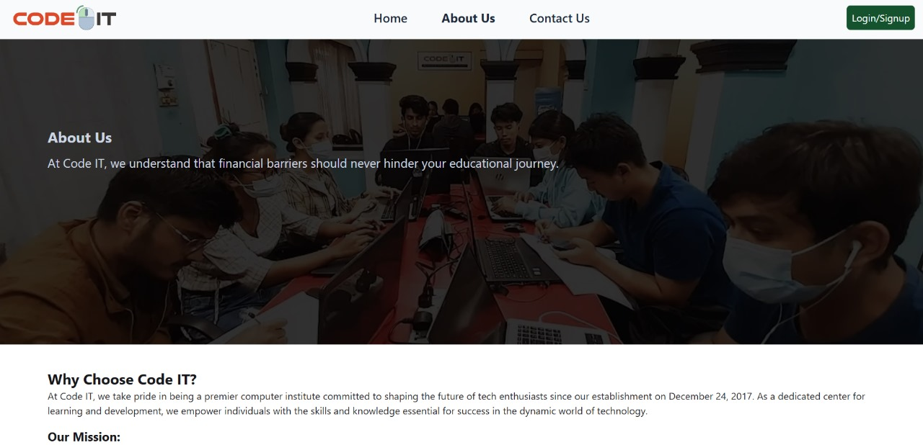

Figure 7 : About page of system

Appendix G

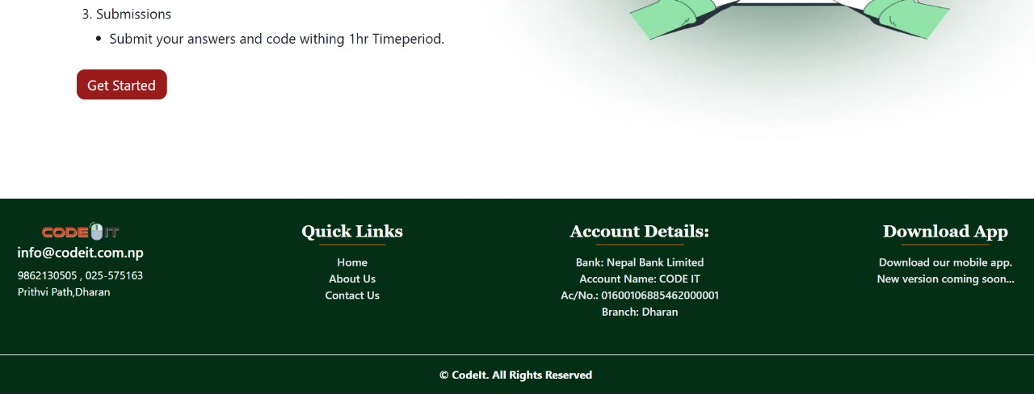

Figure 8 : Footer of system

Appendix H

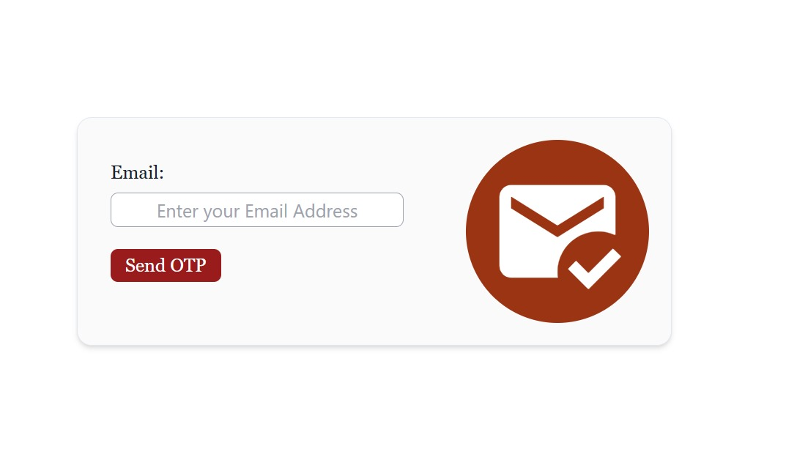

Figure 9 : User Authentication page

Appendix I

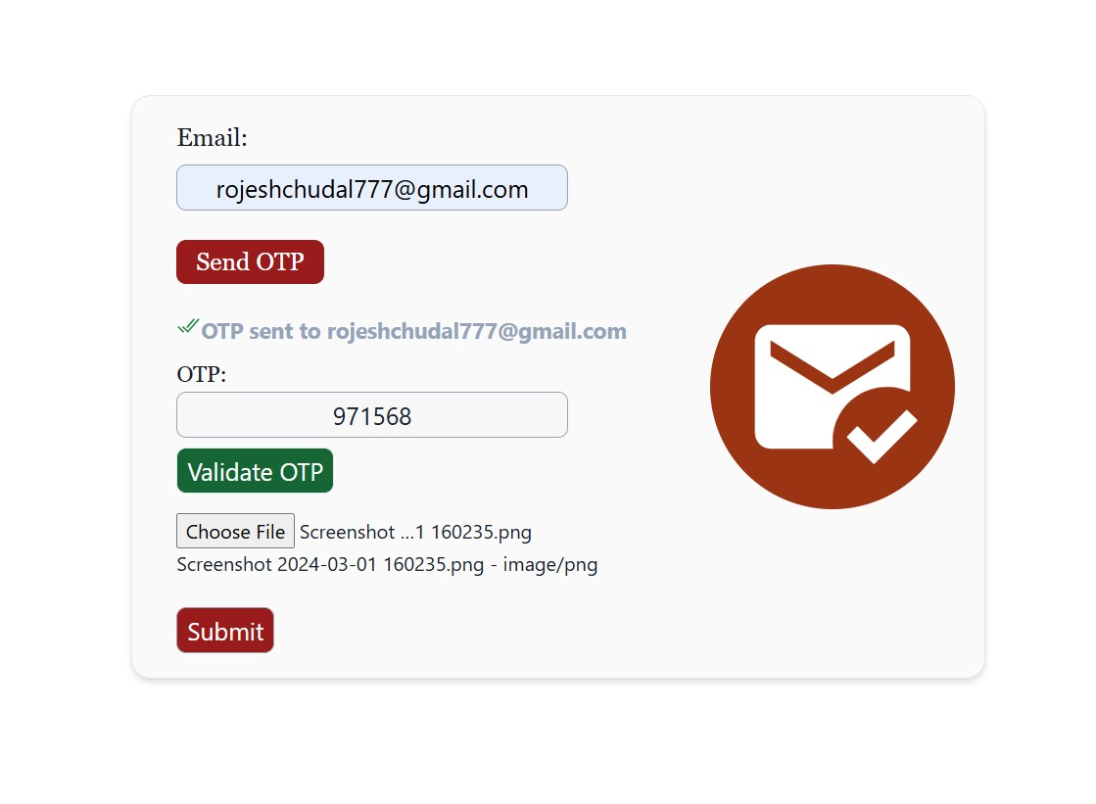

Figure 10 : Final View of User Authentication

Appendix J

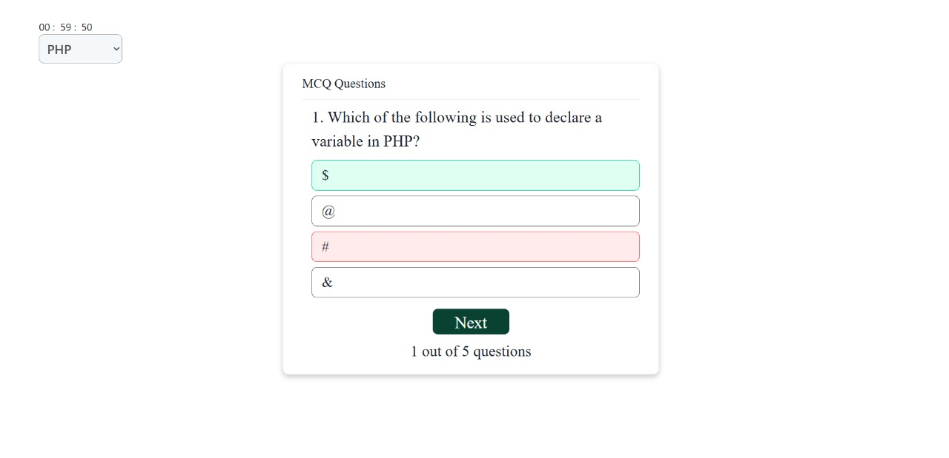

Figure 11 : MCQ page UI design for showing wrong answer

Appendix K

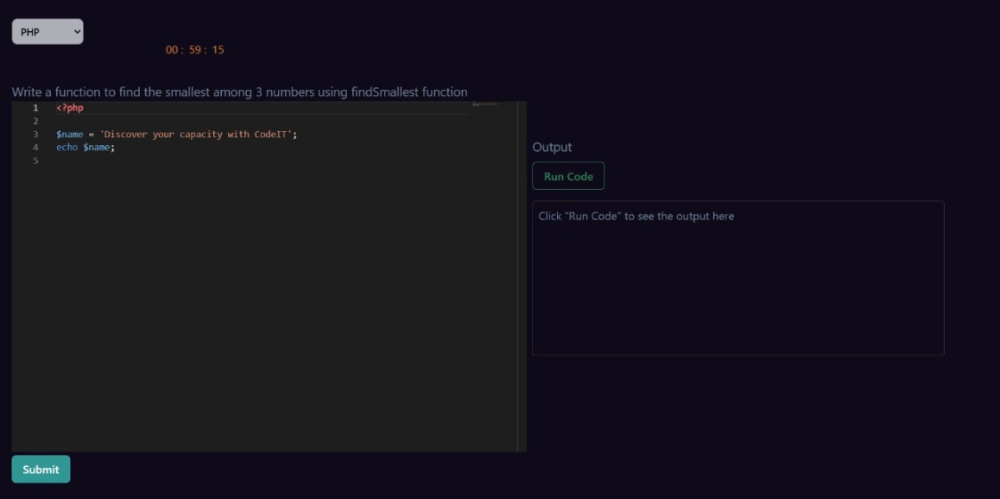

Figure 12 : Code Editor page where user enter answer

Appendix L

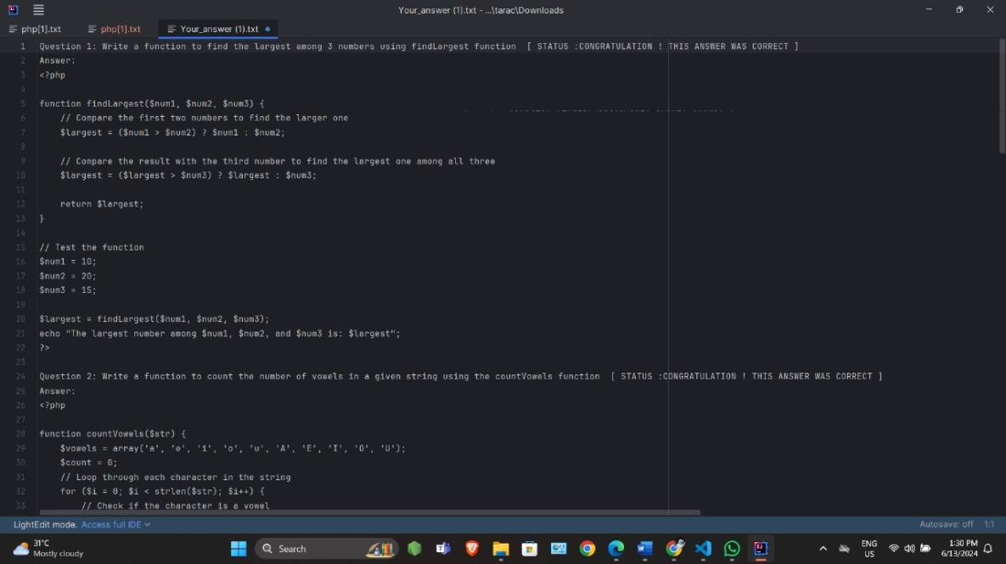

Figure 13 : User reviewing his answer provided in code editor

Appendix M

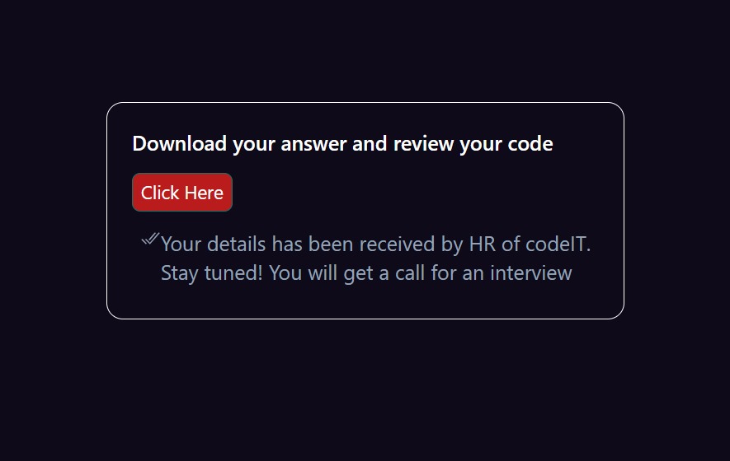

Figure 14 : Sending mail with CV to HR if user passed the exam

Appendix N

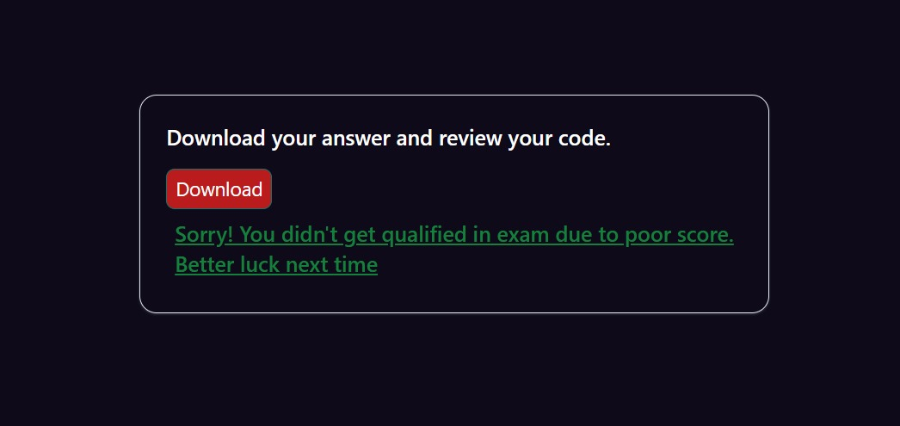

Figure 15 : Interface shown to user if he fails the exam